Preclinical evaluation of AVN-322, novel and highly selective 5-HT₆ receptor antagonist, for the treatment of Alzheimer's disease
Alexandre V. Ivachtchenko,^{a,b} Yan A. Ivanenkov,^{c*} Mark S. Veselov.^{c}

ªAlla Chem LLC, Hallandale Beach, USA; ^{b}Avineuro Pharmaceuticals, Inc., Hallandale Beach, USA; ^{c}Moscow Institute of Physics and Technology (State University), Dolgoprudny city, Russian Federation.
Abstract: In recent years, 5-hydroxytryptamine subtype 6 receptor (5-HT₆ receptor, 5-HT₆R) has rapidly emerged as a promising therapeutic target for the treatment of neuropathological disorders, including Alzheimer’s disease (AD). Evidence indicates that 5-HT₆ receptors are deeply implicated in the processes of learning and memory, while 5-HT₆R antagonists were shown to improve cognition in animal models of cognitive impairment. Moreover, several selective 5-HT₆R ligands are currently undergoing clinical trials against AD. Herein, we present the preclinical development of AVN-322, novel and highly selective 5-HT₆R antagonist, for the treatment of AD. While having nanomolar binding affinity, the lead compound demonstrated the best selectivity index as compared to reference drug candidates. During the pharmacokinetic studies, AVN-322 showed high oral bioavailability and favorable blood-brain barrier (BBB) permeability. In vivo testing revealed its clear cognition enhancing effect without anxiolytic properties that are often associated with serotonin receptor antagonists. AVN-322 significantly restored both scopolamine- and MK-801-induced cognitive dysfunction. Taking into account its good safety profile and favorable pharmacokinetics, AVN-322 can be reasonably regarded as novel drug candidate for the treatment of neurological disorders.
Keywords: 5-HT₆R, antagonists, Alzheimer’s disease, selectivity, preclinical study, pharmacokinetics

1. INTRODUCTION
Alzheimer’s disease (AD) is one of the most devastating neurological disorders and is widespread throughout the world. According to World Health Organization (WHO) reports, more than 36 million people are diagnosed with the disease, and nearly 8 million of new cases of the dementia are reported annually [1]. The mechanisms of AD are still poorly understood, while the available therapy is limited to the symptomatic treatment designed to address the cognitive impairments associated with AD. Drugs approved by FDA, including tacrine, rivastigmine, donepezil and galantamine, represent a group of acetylcholinesterase (AChE) inhibitors which increase the concentration of acetylcholine in the brain, compensating the cholinergic deficit caused by death of cholinergic neurons [2]. Recently approved NDMA receptor antagonist memantine blocks the neurotoxicity induced by glutamate-induced NMDA overactivation which occurs in AD [3]. However, this treatment do not address the process of progressive neurodegeneration, which causes the disease. In recent years, a considerable progress has been made towards the identification of novel targets, deeply implicated in AD neuropathology. Among them, serotonin receptors, particularly 5-HT₁, 5-HT₄ and 5-HT₆, gained an increased attention [4‒6].

*Address correspondence to this author at the Laboratory of Bioinformatics and Medicinal Chemistry, Faculty of Biological and Medical Physics, Moscow Institute of Physics and Technology, P.O. Box: 141700, Dolgoprudny city, Russian Federation; Tel/Fax: +7 (495) 408-45-54; E-mail: yai@chemdiv.com

While serotonin is known to be involved in processes of cognition, memory and learning, certain serotonin receptor ligands were demonstrated to improve memory and cognition in animal models [7]. In a point of fact, several 5-HT₆ receptor antagonists have successfully completed preclinical trials and are currently evaluated in clinics. Despite the failure of multimodal Dimebon, possessing a good affinity for 5-HT₆R and demonstrated the lack of efficiency in Phase III clinical trials against AD [8], novel selective 5-HT₆R antagonists are under active development. Among them, Lu-AE-58054 (Phase III, Lundbeck) [9, 10], PF-05212377 (Phase II, Pfizer) [11, 12], SUVN-502 (Phase I, Suven Life Sciences) [13] and AVN-101 [14] (Phase II, Avineuro) are currently evaluated in clinical trials related to AD neuropathology. Herein, we describe the pharmacokinetic (PK) features, activity, efficiency as well as toxicity profile of novel and highly potent 5-HT₆ receptor antagonist, AVN-322.
2. MATERIALS AND METHods
2.1. Molecule
AVN-322 (N,7-Dimethyl-3-(phenylsulfonyl)-6,7,8,9-tetrahydropyrazolo[1,5-a]pyrido[3,4-e]pyrimidin-2-amine hydrochloride, Fig. 1) is a highly selective 5-HT₆R antagonist, with K_{i}=0.389 (competitive binding assay) and K_{i} = 1.51‒3.7 nM (functional assay) [15]. Its design, synthesis as well as SAR available for its analogs was described previously [16].
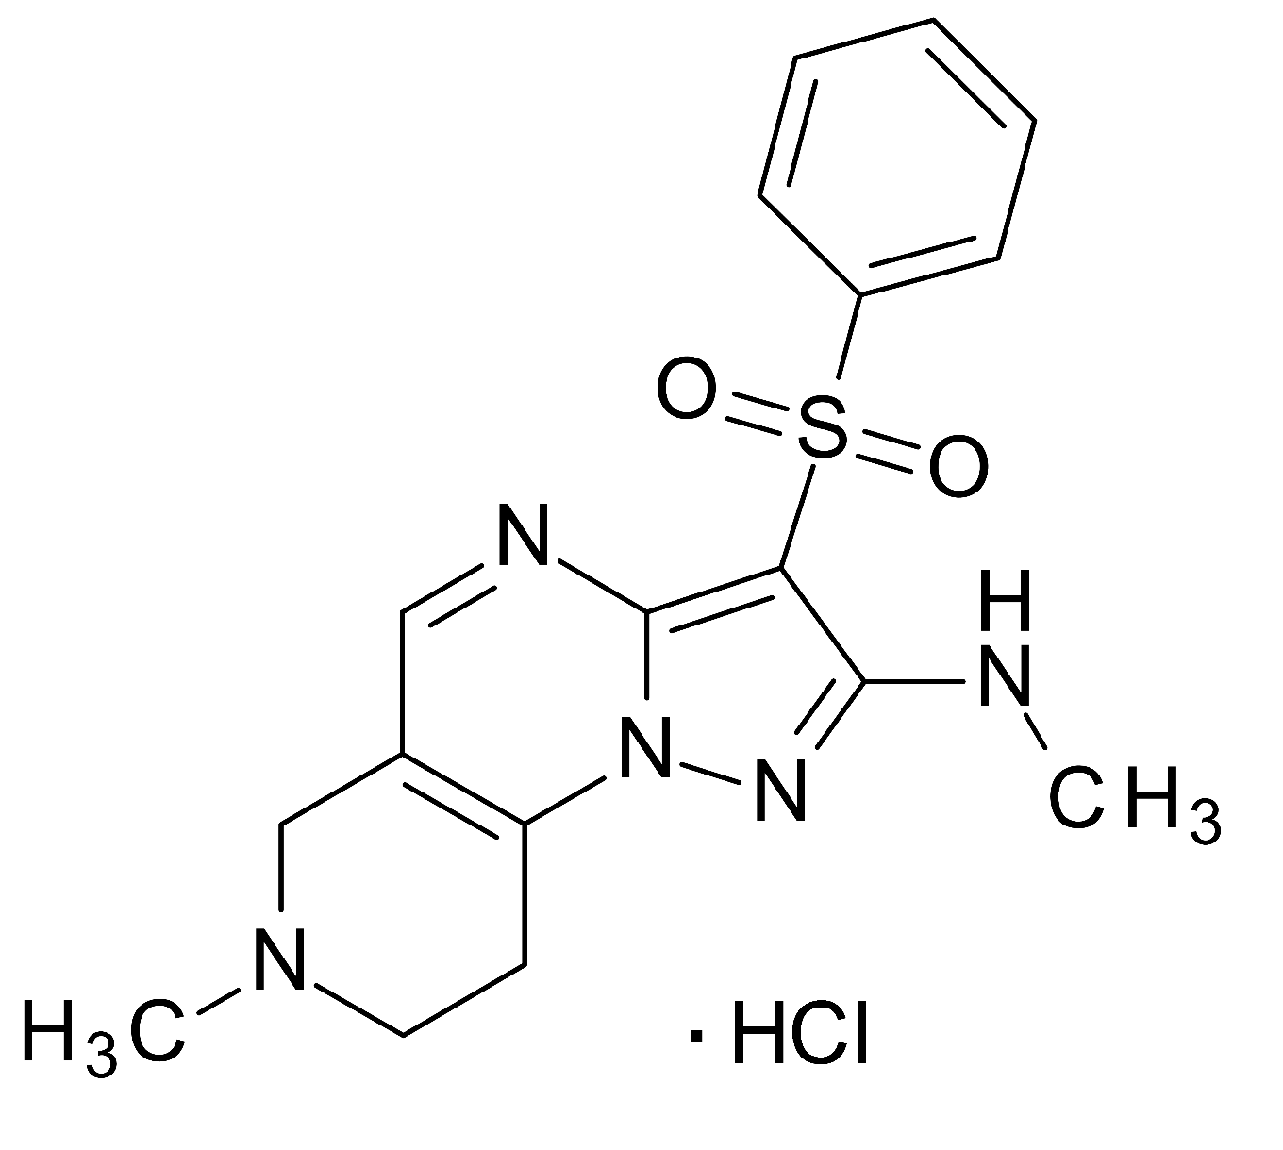
Fig. (1). Structure of AVN-322.
Due to severe limitations in the available paper space, the detailed experimental protocols, procedures as well as lab. tools are properly discussed in supplementary materials (SM). Below, we provide only a brief description.

2.2. Screening
HTS and follow up studies were performed using a recombinant human 5-HT₆R stably expressed in HEK293 cells in a T-RexTM System, a tetracycline regulated mammalian expression assay kit. All the reagents used were obtained from Sigma Chemical Company (St. Louis, MO) unless otherwise stated. Radiochemicals were purchased from Amersham Radiochemicals (GE Healthcare Life Sciences, Pittsburgh, PA). Membrane preparations from cells either transfected with or endogenously expressed receptors and enzymes were obtained from MDS Pharma Services and Eurofins Sc. (Taipei, Taiwan). SK-N-SH cells were from American Type Culture Collection (Manassas, VA). Human recombinant tetracycline-inducible HEK293 5-HT₆R-T-Rex cells were obtained from Etogen Scientific (San Diego, CA). Competitive radio-ligand binding assay for AVN-322 towards a broad panel of therapeutically significant targets has been performed in MDS Pharma Services and Eurofins Sc. following the procedure described in [17].
2.3. Stability in human liver s9 fraction
Analysis of AVN-322 stability in the presence of human liver s9 fraction (CellzDirect, USA) was performed according to the procedure reported in [18].
2.4. Permeability
Permeability of AVN-322 was determined using Caco-2 cells (ATCC cat № HTB-37). Assay was performed according to Caco-2 plate manufacturer guidelines (available on [19]). Lucifer Yellow CH (Sigma, St Louis, MO, cat № LO144) was used as a control for 100% confluence.
2.5. Interaction with P-glycoprotein (P-gp)
Two different approaches, luminescent ATPase assay with P-gp-Glo System and Caco-2 monolayer efflux assay, were used to study P-gp/AVN-322 interaction. The first assay has been applied to detect the effects of compound on recombinant human P-gp in a cell membrane fraction. The assay relies on the ATP dependence of the light-generating reaction of firefly luciferase. MultiScreen Caco-2 Assay System (Millipore Corp., USA) was used for the monolayer efflux studies. Caco-2 cells are morphologically and functionally very similar to intestinal barrier cells and are frequently utilized as in vitro permeability model. The cells also express a variety of transporters including P-gp, thus may be used in P-gp-mediated transport studies. Particularly, the effect of AVN-322 on Rhodamine¹²³ (Rh¹²³) transport has been estimated.
2.6. Interaction with cytochromes
The interaction of AVN-322 with CYP1A2, CYP2C9, CYP2C19, CYP2D6, CYP2E1 and CYP3A4 (Invitrogen Vivid® CYP450 Screening Kits, Cat. no. P2863, P2859, P2864, P2972, P3021, P2856) and CYP2B6 (BD Biosciences P450 Inhibition Kit, Cat. no. 459220) was studied in full accordance with the manufacturer’s protocols [20].
2.7. Animals (pharmacokinetics study)
Pharmacokinetics of AVN-322 was studied using 24 SHK mice after single i.p. injection in the dose of 5 mg/kg. Pharmacokinetic properties of the title compound were also evaluated using 24 male rats of WAQ strain after single i.v. (2 mg/kg) or p.o. (10 mg/kg) administration. Oral bioavailability of AVN-322 was calculated based on the obtained results as a ratio of AUQ_{0→t}(p.o.)/AUQ_{0→t}(i.v.). We also investigated the PK features of AVN-322 in rat brain. The studies were performed on male Wistar rats after single p.o. (10 mg/kg) or i.v. (2 mg/kg) administration. CSF/plasma ratio was studied in 6 male Wistar rats administered with AVN-322 in the dose of 10 mg/kg (p.o.). Preliminary escalating dose study was conducted in rats. AVN-322 was administered per os in the dose of 10, 30, and 100 mg/kg to the 6 male Wistar rats. After 10 minutes, animals were sacrificed and plasma samples were collected and subsequently analyzed for AVN-322 concentration using LC-MS/MS API2000. Pharmacokinetic in 4 dogs was evaluated after single i.v. (2 mg/kg) or p.o. (10 mg/kg) administration. PK features of AVN-322 were also investigated in 2 rhesus monkeys. Animals were not used in other studies for at least 2,5 months prior to the pharmacokinetics experiments. Animals were kept in cages, feeding was performed with usual balanced fodders, eggs, vegetables and fruits. Clinical status of animals and their behavior were normal. Animal IDs, the route of administration and doses of the tested compounds are presented in SM (Supplementary table 12, 13). Maintenance and care were in accordance with the Guide for the Care and Use of Laboratory Animals [21].
2.8. In vivo efficacy
The rats (Wistar and Sprague-Dawley, 160–300 g, 13–14 wk old) and mice (BALB/c and SHK, 18–32 g, 8–9 wk old) were obtained from the State Scientific Center (GU NC) of Biomedical Technologies of the Russian Academy of Medical Sciences (RAMS) “Andreevka” (Moscow region). Before the studies, the animals were quarantined for 7 days. During this period, the animals were monitored for the presence of possible diseases. They were housed in standard plastic cages under controlled conditions: temperature 19–25 °C, humidity 50–70%, 12:12 h light-dark cycle, concentration of carbon dioxide <0.15% (vol.), concentration of ammonia <0.001 mg/L. The animals were monitored at least once daily (or 1 h after subacute injections). The results of monitoring were traced in a laboratory register. The specificity of the subjects used are listed in Table 1 (see below).
2.10. hERG channels inhibition
Potassium current was measured using the patch clamp technique in Molecular Devices’ Patch Express 7000A following the procedure described in SM.
2.11. Toxicity and side-effects
LD₅₀, MTD and 14-days toxicity of AVN-322 were investigated in SHK strain male mice (20–25 g). Long-term 180-days toxicological study was also performed in 80 Wistar rats (8 wk old) and 8 rabbits. In addition, six healthy Rhesus Macaques (Macaca Mulatta, 3 males and 3 females) were used to determine 30-days toxicity of AVN-322 (10 mg/kg, p.o.). Pathomorphological examination, including histopathology and macroscopic study, was performed on the 181th day of experiment after per os administration of AVN-322 in the doses of 10, 30 and 100 mg/kg (rats) and 10 mg/kg (rabbits). In vitro mutagenicity was estimated using Ames MPF Test, while mutagenicity in vivo was analyzed in C57BL/6 mice (18–20 g, 8–12 wk old). All the details of the procedures mentioned above are conveniently described in SM with corresponding tables and figures.
2.12. Statistical analysis
All data were fed into Excel 2003 spread sheets. Subsequent statistical analyses were performed using Statistica 6.0 software. The obtained results are presented as mean ± standard error of the mean (S.E.M.), unless otherwise stated. A p-value less than 0.05 was considered statistically significant. LD₅₀ was calculated from the mortality rate table according to the method of Finny using BioStat 2006 program.

3. RESULTS
3.1. In vitro target profile
AVN-322 was extensively studied using various in vitro binding and functional assays and was characterized as a highly potent and selective 5-HT₆R antagonist. AVN-322 inhibited the binding of radiolabeled [³H]LSD to 5-HT₆R in a concentration-dependent manner with K_{i}=0.389 nM and IC₅₀=0.84 nM (Fig. 2A). In functional assay, the compound was shown to inhibit cAMP production induced by serotonin in HEK-293 cells with EC₅₀=7.2 nM and K_{i} = 1.51‒3.7 nM (Fig. 2B). Characterization of selectivity profile revealed no significant activities of AVN-322 against more than 60 therapeutic targets including other GPCRs, ion channels and transporters (Supplementary Table 1, 2). AVN-322 demonstrated >2,500-fold selectivity for 5-HT₆R which is 50- and 20-fold higher than that of SB-742457 [22] and Lu-AE-58054 [23], respectively. The compound was shown to exhibit high selectivity towards 5-HT₆R over other serotonin receptor sub-types except 5-HT_{2B}R [16].
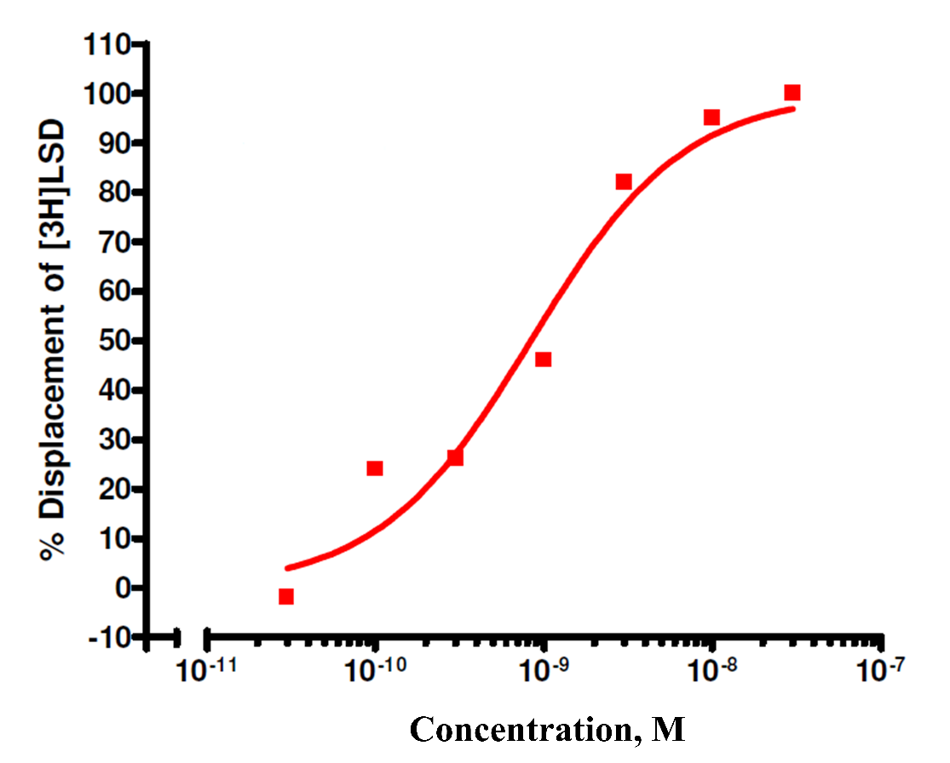
A
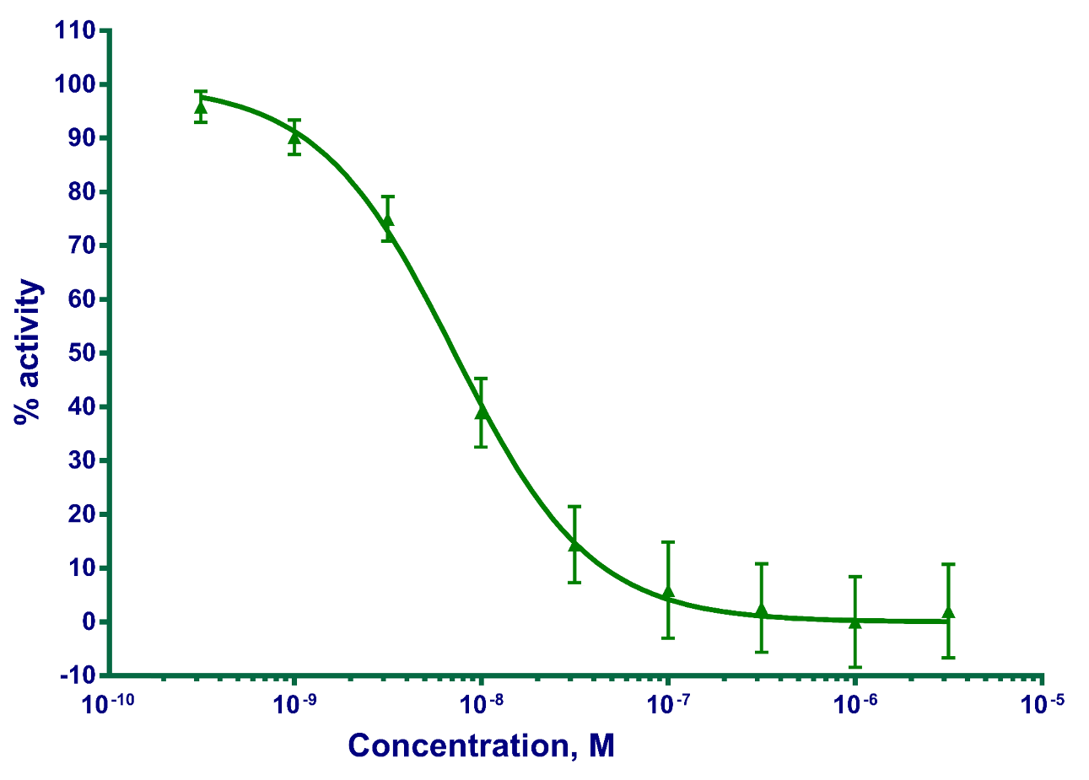
B
Fig. (2). Activity of AVN-322: (A) competitive displacement of radio-labeled [³H]LSD from 5-HT₆R expressed in the cell membrane fraction; (B) dose-dependent inhibition of cAMP production induced by serotonin in HEK293 cells transfected with functional human 5-HT₆R.
In a cell-based functional assay AVN-322 was characterized as a weak 5-HT_{2B}R antagonist with an IC₅₀ value of 6.2 μM, which is >160-fold higher than that for 5-HT₆R and is not associated with any potential therapeutic liability (Supplementary Fig. 2). AVN-322 was also tested for its ability to block hERG channel using HEK cells stably expressing the hERG potassium channel. The potency of the compound to block hERG channel was three orders of magnitude lower than that of blocking serotonin-induced cell response mediated through 5-HT₆R (Supplementary Fig. 3). With an IC₅₀ value of 54 μM in patch-clamp assay (ion current inhibition), AVN-322 is not expected to affect Q-T interval in vivo.
3.2. In vivo efficacy
Antiamnesic, antipsychotic and nootropic activities of AVN-322 were examined in different in vivo models, including passive avoidance test [24, 25] and Morris water maze test [26, 27] which are frequently applied in anti-AD drug design and development. Treatment with AVN-322 has significantly improved learning and memory in exposed animals and restored both MK-801- and scopolamine-induced cognitive impairment. While testing in exploratory low mice with cognitive deficit AVN-322 showed a marked cognition-enhancing effect comparable with that of piracetam. In acoustic startle reflex test AVN-322 demonstrated an antipsychotic activity by preventing the disruptive effect of pro-psychotic agent apomorphine. In most measures, the effects produced by AVN-322 were considerably higher than that observed for PRX-07034 and SB-742457 or comparative to donepezil, memantine, buspirone, lorazepam, piracetam, haloperidol and tacrine (Table 1).

Table 1. In vivo efficacy of AVN-322
Description | Study | Subject | Brief summary
Scopolamine-based models of amnesia | Passive avoidance test | BALB/c mice (24–25 g) | In most measures AVN-322 was more effective than memantine and tacrine. The most pronounced effect of AVN-322 was observed in 0.2 mg/kg dose administered per os 15 min before the test.
Scopolamine-based models of amnesia | Passive avoidance test | Male and female Wistar rats (160–185 g, 10 wk old) | Given per os AVN-322 significantly restored memory in Scopolamine-treated rats.
Scopolamine-based models of amnesia | Novel object recognition test | SHK mice (24–30 g) | AVN-322 showed an anti-amnesic effect exceeding that of tacrine.
Scopolamine-based models of amnesia | Morris water maze test | BALB/c mice (24–25 g) | AVN-322 in the doses of 0.1 and 1.0 mg/kg (i.p.) showed an antiamnestic activity exceeding that of AChE inhibitors donepezil and tacrine.
MK-801-based models of amnesia | Passive avoidance test | BALB/c mice (24–25 g) | AVN-322 was one the most active compounds in the test compared to memantine, tacrine, SB-742457 and PRX-07034.
MK-801-based models of amnesia | Novel object recognition test | SHK mice (24–30 g) | AVN-322 as well as all tested reference molecules (tacrine, memantine and SB-742457) revealed an anti-amnesic effect in this test.
MK-801-based models of amnesia | Morris water maze test | BALB/c mice (24–25 g) | The control group animals demonstrated successful learning, since they spent more time in the quadrant of the platform location on the 3rd day. MK-801 at the dose of 0.2 mg/kg (i.p.) disrupted training process under the described conditions. At the same time, co-administration of memantine or AVN-322 (1 mg/kg) significantly improved learning in experimental conditions.
Nootropic activity | Cognitive deficit in exploratory low SHK mice | SHK mice (22-32 g) | The test revealed that both piracetam and AVN-322 produce a marked decrease in number of visits during the 1st patrolling demonstrating a clear cognition-enhancing effect.
Antipsychotic activity | Acoustic startle reflex test | Naive male SHK (24–30 g) mice | Results of the test showed that non-treated mice demonstrated about 53% pre-pulse inhibition. Pro-psychotic agent apomorphine reduced this value thus showing deterioration of an ability for filtration of sensory signals. Haloperidol (1 mg/kg) and AVN-322 (1 mg/kg) prevented disruptive effect of apomorphine on startle pre-pulse inhibition.
Anxiolytic activity | Elevated plus maze | BALB/c mice (24–25 g) | Buspirone and lorazepam produced clear anxiolytic effect in the elevated plus maze test, while AVN-322 was almost not active in that test.

3.3. In vitro ADME features
With T_{1/2} of more than 120 minutes and maximal degradation of only 15.3% after 2 h of incubation, AVN-322 was characterized as quite stable in the presence of s9 human liver fraction (Fig. 3). Analysis of the compound (500 ng/ml) stability in the human plasma showed only 15.8% reduction in the original compound concentration during the first 30 minutes of the incubation (Supplementary Fig. 8).
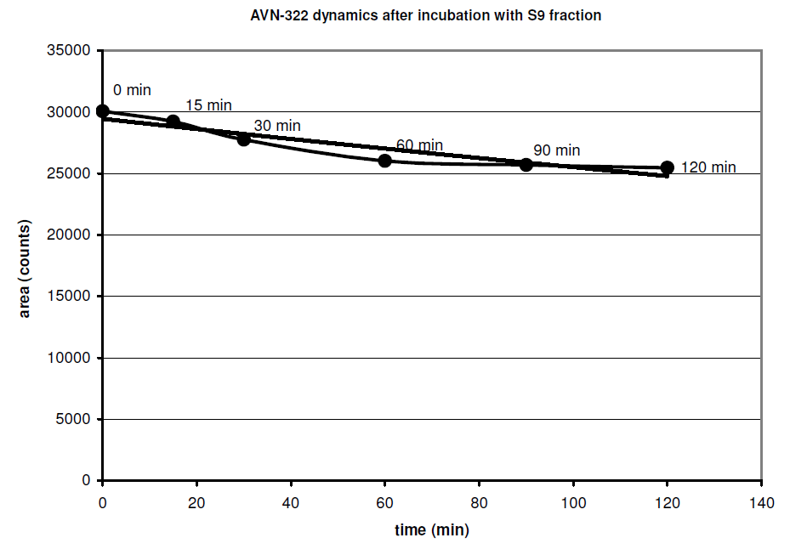
Fig. (3). Dynamics of AVN-322 concentration during incubation with human s9 fraction
AVN-322 binding to human plasma proteins was measured using the Pierce rapid equilibrium device (RED) system. According to the obtained data 70.1% of the compound is bound to human plasma proteins (Table 2). The binding observed in rat plasma was markedly higher (PPB=85.7%).
Table 2. Rat and human plasma protein binding of AVN-322
Concentration, mg/ml | Rat plasma, % |  | Human plasma, %
Concentration, mg/ml | Free | Bound | Free | Bound
0.5 | 10.9 | 89.1 | 29.5 | 70.5
5 | 17.7 | 82.3 | 30.4 | 69.6
Permeability was determined using Caco-2 cells (for details, see SM). It was demonstrated that AVN-322 has a high permeability in Caco-2 cells assay conditions (P_{app}(10⁻⁶ sm/s) = 48.5; LC/MS/MS; Supplementary Table 4) To study the interaction of AVN-322 with P-gp two different approaches were used: the ATPase assay with P-gp-Glo System and Caco-2 monolayer efflux assay. It was found that AVN-322 had no effect on P-gp-ATPase activity in concentration range of 0.1–100 μM (Supplementary Fig. 9). Despite the good passive permeability demonstrated in MultiScreen Caco-2 assay system, suggesting that AVN-322 does not undergo efflux and is not transported by P-gp, there is an opinion that the monolayer efflux assays tend to be insensitive to highly permeable compounds (P_{app}(A-B)>30×10⁻⁶ cm/s), yielding false negative results [28]. While not effluxed by P-gp, the compound could affect the transport of other P-gp substrates due to the complexity of the possible molecule–protein interactions. To confirm the expression of functional P-gp and to define whether AVN-322 inhibited the P-gp-mediated transport we performed the monolayer efflux studies in Caco-2 cells using Rh¹²³ as well-characterized and easily detectable P-gp substrate. According to the obtained results, AVN-322 did not demonstrate any statistically relevant inhibition of P-gp-mediated transport of Rh¹²³ (Supplementary Fig. 10) Thus, in both tests AVN-322 did not show any interaction with P-gp. Additionally, the investigation of the compound interactions with cytochromes revealed that AVN-322 did not influence the activity of CYP1A2, CYP2B6, CYP 2C19, CYP 2C9, CYP2D6, CYP2E1 and CYP3A4 enzymes (Supplementary Fig. 4‒7).

3.4. Pharmacokinetics
Pharmacokinetics of AVN-322 was examined in mice, rats, dogs and monkeys after i.v., p.o. and i.p. administration. Main pharmacokinetic parameters are summarized in Table 3. The time to maximal plasma drug levels in rats after p.o. administration was 5 min, compared to 38 min in monkeys and 120 min in dogs. The elimination half-lives after single p.o. dosing in monkeys and dogs were approximately 1.5 h and 3 h, respectively, while in rats T_{1/2} of AVN-322 equaled to almost 1 h. Oral bioavailability in rats was approximately 12% compared to 18% in dogs and 51% in monkeys given AVN-322. We also investigated the BBB permeability and pharmacokinetic features of the compound in rat brain.

Table 3. Main PK parameters of AVN-322
Subject | Dose (mg/kg) | T_{max} (min) | C_{max} (ng/ml) | T_{1/2} (min) | AUC_{0→∞} (ng*min/ml)*10³ | F, %
i.p.
Mice | 5 | 5 | 2200.3 | 27.3 | 32.1 | -
i.v.
Rats | 2 | 5 | 1375.3 | 19.9 | 35.5 | -
Dogs | 2 | 1 | 1350 | 30.6 | 52.2 | -
Monkeys | 2 | 1 | 2355 | 40.9 | 89.8 | -
p.o.
Rats | 10 | 5 | 507.7 | 52.22 | 21.3 | 12.3
Dogs | 10 | 120 | 183.5 | 180.1 | 46 | 18
Monkeys | 10 | 38 | 1479 | 97.1 | 21.2 | 51

Among other pharmacokinetic parameters, permeability across the blood-brain barrier is known to be one of the most crucial features of CNS-active compounds. For 5-HT₆ receptor ligands with various chemotypes, including indoles, their isosteric analogs and non-sulfonyl compounds, brain/plasma (B/P) ratio was reported to lie generally within the range of 0.5–23 [23, 28‒33]. As for bisaryl sulfonamide derivatives, the following B/P ratio was reported: 0.1 (SB-214111) [34], 0.9 (indole-based analogue by Suven Life Sciences) [35], 0.19 (SB-357134) [36], 0.24 (Ro 66-0074) [37], 1.0 (4,5-dihydro-1H-pyrazole-containing analogue) [38]. However, other pharmacokinetic parameters, including t_{1/2} (brain), Cl (brain), bioavailability, etc., significantly influence the therapeutic potential of such molecules and should be appropriately considered. Thus, we have studied the pharmacokinetics of AVN-322 in rat brain after single i.v. (2 mg/kg) or p.o. (10 mg/kg) administration. Main pharmacokinetic parameters are presented in Table 4. According to the obtained results, the B/P ratio of AVN-322, calculated as BrAUC_{0→∞}/PlAUC_{0→∞} is 25%.
Table 4. PK parameters of AVN-322 in rat brain
Dosing | T_{max} (min) | C_{max} (ng/ml) | T_{1/2} (min) | AUC_{0→∞} (ng*min/ml)  *10³
2 mg/kg, i.v. | 5 | 511 | 45 | 12.1
10 mg/kg, p.o. | 5 | 235.9 | 44.4 | 6.4
In addition to the parameters presented above, we have studied the presence of AVN-322 in cerebrospinal fluid (CSF). The compound was administered per os in the dose of 10 mg/kg to the 6 male Wistar rats. After 60 min animals were anaesthetized and samples of CSF, brain and plasma were taken. CSF samples were carefully monitored for the absence of blood contaminations. AVN-322 was extracted from CSF, brain and plasma with acetonitrile and the concentrations were detected using API2000 LCMS/MS. As depicted in Fig. 4, the average concentration of AVN-322 in rat CSF after oral administration in the dose of 10 mg/kg is 247 ng/ml, CSF/plasma ratio is 49% and B/P ratio is 46.5%.
3.5. Safety pharmacology and side-effects
In SHK strain male mice, the LD₅₀ value was determined after i.p. injection of AVN-322 in different doses ranged from 500 to 2000 mg/kg and equaled to 1250 ± 155 mg/kg (Supplementary Table 15). During the 14-days toxicity study in mice, AVN-322 was injected i.p. once daily at the dose of 20 mg/kg.
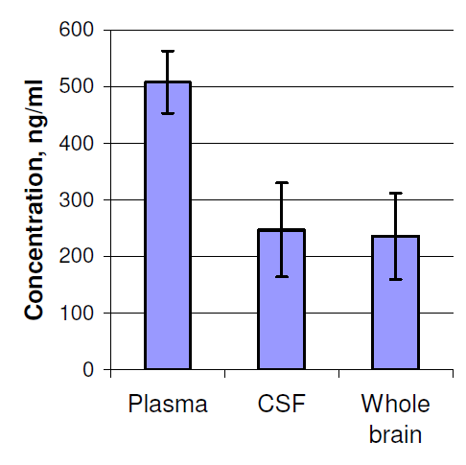
Fig. (4). Relative concentrations of AVN-322 in CSF and plasma
No statistically significant change in the enzymatic activity of alanine aminotransferase (ALT) and aspartate aminotransferase (AST) as well as in the level of glucose and urea in plasma was observed after 14-days treatment with AVN-322 (Supplementary Fig. 39‒43).
In monkeys, 30-days treatment with AVN-322 (10 mg/kg, p.o.) did not produce any toxic effects. During the study, no weight loss or changes in plasma biochemistry markers were observed, except for minor alterations in ALT levels, which could be explained by ketamine tranquilization of the animals (Supplementary Fig. 44‒49).
Chronic toxicity was assessed after the daily administration of AVN-322 for 180 days in the doses of 10, 30 and 100 mg/kg in rats. No weight changes were noticed during the treatment with AVN-322 (Supplementary Fig. 50, 51). After the hematological investigation, a number of changes in blood parameters were revealed, including alterations in leukocytes and lymphocytes levels, however these changes remained within the limits of normal physiology. The greatest changes were observed in the markers of liver function: the maintenance of general protein, the activity of transaminases and the level of bilirubin (Supplementary Fig. 52‒56). It may point to hepatocytes damage and bilious pigments infringement. Generally changes of the listed indicators have functional character, and, possibly, depend on dynamics of the adaptive processes related to AVN-322 administration. The most essential changes were observed in an intermediate dose and were absent in the higher dose. Mass coefficients of internal organs in AVN-322-treated groups did not differ from the same in animals of control group (Supplementary Fig. 75). A statistically significant increase of mass coefficient of the liver in animals of both sexes was observed as the result of the administration of AVN-322 at the dose of 100 mg/kg. Simultaneously, in the male rats of this dose group the decrease of the mass coefficient of the adrenal glands was observed. In females (100 mg/kg) increase in the mass coefficient of kidneys was observed as well. An increase in the mass coefficient of spleen was noted in the females of 10 mg/kg group and in the males of intermediate dose group (30 mg/kg). However, the macroscopic study of the organs did not reveal any difference between placebo and AVN-322-treated animals (Supplementary Fig. 57‒74). All the inspected organs were of regular size and structure, without any pathological changes except that corresponded to the chosen method of euthanasia.
During another 180-days study in rabbits, administered AVN-322 per os in the dose of 10 mg/kg, no changes in body weight and blood cell counts of the animals were revealed (Supplementary Fig. 76, 77). Certain changes in lymphocytes and other cells were within the limits of physiological standards. Observed reduction of the albumin fraction, increases in the levels of globulin ALT suggest certain alterations of the liver function (Supplementary Fig. 78‒82). However, such outcome is not supported by the results of the pathomorphological study that revealed no changes in size, shape, mass coefficient or histological structure of liver. The higher values of the mass coefficients of lungs, brain and heart, probably, were related to the plethora of these organs in animals of AVN-322-treated groups (Supplementary Fig. 98, 99).
According to the results of Ames test, AVN-322 was not mutagenic in concentrations up to 300 μM (Supplementary Fig. 100). Mutagenicity in vivo was assessed by the method of chromosomal aberrations in the bone marrow cells of mice. At doses 5, 105, 220 mg/kg AVN-322 did not possess the mutagenic activity (Supplementary Table 19). It was found that AVN-322 has statistically insignificant tendency to cause bradycardia and hypotension (Supplementary Fig. 101‒103). It was also demonstrated that AVN-322 has no addiction potential and influence on gastrointestinal transit velocity (Supplementary Fig. 104, 105). At the dose of 0.2 mg/kg, AVN-322 did not produce any cataleptic effect while the probability to cause extrapyramid symptoms (tardive dyskinesia) was much lower compared to that of classic neuroleptic drug haloperidol (Supplementary Fig. 106).

4. DISCUSSION
During the last decade, 5-HT₆ receptor has been increasingly recognized as a promising target for the treatment of neurodegenerative disorders. A number of 5-HT₆R antagonists demonstrated beneficial cognition-enhancing effects in animal models thereby providing the evidence for the involvement of 5-HT₆R in the processes of memory and learning [5, 39]. Through the mechanisms by which 5-HT₆R antagonists enhance cognition are still unclear, several compounds have successfully reached clinical trials as cognitive-enhancing drug candidates [40]. Interestingly, clinical studies against AD have been recently initiated towards the molecules that were previously developed as anti-schizophrenic agents. Thus, Lu-AE-58054 was undergoing Phase II clinical trials in schizophrenic patients with cognitive impairment [41], but in 2010 Lundbeck discontinued the development of the compound due to the lack of efficacy [42]. After the relative success achieved in Phase II evaluation of Lu-AE-58054 in combination with donepezil [43], in 2013 the company initiated an extensive Phase III program of the compound as adjuvant therapy against AD [44]. Initially designed for the treatment of schizophrenia, anxiety, cognitive disorders and depression, another 5-HT₆R antagonist SB-742457 [45‒49] was successfully tested in animal models of cognition impairment and was subsequently evaluated in clinics. In Phase II clinical trial the compound was compared to placebo and donepezil and demonstrated promising efficacy and safety [50]. Overall, SB-742457 was evaluated in 13 clinical studies involving over 1,250 healthy subjects and AD patients. Despite the results of the studies providing some evidence for the efficacy of SB-742457 in mild to moderate AD, no relevant proofs were obtained following this indication [51]. However, Axovant Sciences has recently initiated a confirmatory global Phase III evaluation of RVT-101 (re-named SB-742457) in patients with mild to moderate Alzheimer's disease [52]. In the current paper, we present the preclinical development of potent and highly selective 5-HT₆R antagonist AVN-322 for the treatment of AD. According to the obtained results, considerable improvements in cognition and learning were observed in different behavioral models during the treatment with AVN-322. In vivo efficacy of AVN-322 was compared that of well-known drugs memantine (launched in 2015 by Actavis) and tacrine (launched in 1993 by Shionogi) and also SB-742457 and PRX-07034 [53], compounds that are under active clinical development. It was shown that AVN-322 significantly restored both scopolamine- and MK-801-induced cognitive dysfunction in all used behavioral tests. In general, the cognition restorative effect of the lead molecule was generally more prominent compared with that of the reference compounds. It should be noted that a clear cognition enhancement effect could be observed in naive animals without any chemically induced memory impairment. AVN-322 demonstrated an antipsychotic activity compared to that of haloperidol and did not show any significant anxiolytic effects. In addition to a high efficacy in in vivo models AVN-322 has favorable pharmacokinetics (more than 50% bioavailability in primates and a high brain/CSF penetration) and toxicological profile that makes it promising candidate for clinical trials in AD patients.
5. CONCLUSION
Accumulated preclinical data and beneficial results of the clinical trials support the therapeutic potential of 5-HT₆R antagonists for the treatment of Alzheimer’s disease. During the preclinical evaluation, highly potent and selective 5-HT₆R antagonist AVN-322 demonstrated a substantial enhancement of cognition in both chemically impaired and naive animals. The observed effects were considerably higher than that observed for PRX-07034 and SB-742457 or comparable with donepezil, memantine and other well-known drugs. Along with the high efficiency and low toxicity, AVN-322 has a favorable pharmacokinetic profile, including good oral bioavailability and BBB permeability. Currently, AVN-322 is undergoing clinical evaluation against AD and the results of Phase I study will be disclosed in the follow up communication.
CONFLICT OF INTEREST
None of the authors have any conflicts of interest.
ACKNOWLEDGEMENTS
This study was supported by research grant from the Russian Science Foundation, Moscow, Russia.
We would like to thank Yan Lavrovsky (R-Pharm Overseas, Inc., USA), D.V. Kravchenko, (Chemical Diversity Research Institute, Russia), R.N. Karapetian (Chemical Diversity Research Institute, Russia), I.M. Okun (ChemDiv, Inc., USA), V.I. Kazey (Exactelabs, Russia) and R.M. Salimov (Incuron LLC, Russia) for their help with experimental work, interpretation of the results and manuscript preparation.
SUPPLEMENTARY MATERIAL
The supplementary material is available in the electronic version of this article.

REFERENCES
- World Health Organization. Available from: http://www.who.int/en
- Mangialasche F, Solomon A, Winblad B, Mecocci P, Kivipelto M. Alzheimer’s disease: clinical trials and drug development. Lancet Neurol 9:702-716 (2010).
- Thomas SJ, Grossberg GT. Memantine: a review of studies into its safety and efficacy in treating Alzheimer’s disease and other dementias. Clin. Interventions Aging 4:367-377 (2009).
- Geldenhuys WJ, Van der Schyf CJ. The serotonin 5-HT6 receptor: a viable drug target for treating cognitive deficits in Alzheimer’s disease. Expert Rev Neurother 9(7):1073-1085 (2009).
- Geldenhuys WJ, Van der Schyf CJ. Serotonin 5-HT6 receptor antagonists for the treatment of Alzheimer’s disease. Curr Top Med Chem 8(12):1035-1048 (2008).
- Glennon RA, Siripurapu U, Roth BL, Kolanos R, Bondarev ML, Sikazwe D, et al. The medicinal chemistry of 5-HT6 receptor ligands with a focus on arylsulfonyltryptamine analogs. Curr Top Med Chem 10(5):579-95 (2010).
- Geldenhuys WJ, Van der Schyf CJ. Role of serotonin in Alzheimer's disease: a new therapeutic target? CNS Drugs 25(9):765-781 (2011).
- Medivation and Pfizer Announce Results from Phase 3 Concert Trial of Dimebon in Alzheimer’s Disease. January 16, 2012. Available from: http://www. pfizer.com/news/press-release/press-release-archive-detail/medivation_and_pfizer_announce_results_from_phase_3_concert_ trial_of_dimebon_in_alzheimer_s_disease
- Schneider LS. Idalopirdine for Alzheimer's disease: written in the stars. Lancet Neurol 13(11):1063-1065 (2014).
- Marazziti D, Rutigliano G, Catena-Dell'Osso M, Baroni S, Dell'Osso L. The 5-HT6 receptor antagonism approach in Alzheimer's disease. Drugs Fut 39(2):133 (2014).
- Study Evaluating The Safety And Efficacy Of PF-05212377 Or Placebo In Subjects With Alzheimer's Disease With Existing Neuropsychiatric Symptoms On Donepezil. NCT01712074. Available from: https://clinicaltrials.gov/ct2/show/NCT01712074
- Bell J, Baird-Bellaire S, Leil T, Comery T, Plotka A, Antinew J, et al. Single and multiple dose safety, tolerability and pharmacokinetics of a novel 5HT6 receptor full antagonist (SAM-760) for the treatment of the symptoms of Alzheimer's disease in healthy young adults and elderly subjects. Alzheimer's Assoc Int Conf (AAIC) Abst P4-214 (2011).
- Nirogi R, Jayarajan P, Abraham, R, Kandikere V. A safe, potent, selective, brain penetrant and orally active 5-HT6 receptor antagonist SUVN-502. 12th Int Conf Alzheimer's Dis Relat Disord (ICAD) Abst P2-264 (2009).
- Lavrovsky Y, Ivachtchenko AV, Morozova M, Salimov RM, Kasey V. Preclinical and early clinical studies of AVN-101, a novel balanced molecule for the treatment of Alzheimer's disease. Alzheimer's & Dementia 6(4):S583 (2010).
- Ivashchenko AA, Kysil VM, Savchuk NF, Ivashchenko AV. 2-Amino-3-sulphonyl-tetrahydro-pyrazolo[1,5-a]pyrido-pyrimidine antagonists of serotonin 5-HT6 receptors, methods for the production and use thereof. Patent WO 2009136813, 2009.
- Ivachtchenko AV, Golovina ES, Kadieva MG, Kysil VM, Mitkin OD, Vorobiev AA, et al. Antagonists of 5-HT₆ receptors. Substituted 3-(phenylsulfonyl)pyrazolo[1,5-a]pyrido[3,4-e]pyrimidines and 3-(phenylsulfonyl)pyrazolo[1,5-a]pyrido[4,3-d]pyrimidines-Synthesis and 'structure-activity' relationship. Bioorg Med Chem Lett 22(13):4273-4280 (2012).
- Okun I, Tkachenko SE, Khvat A, Mitkin O, Kazey V, Ivachtchenko AV. From anti-allergic to anti-alzheimer’s: molecular pharmacology of Dimebon. Curr Alzheimer Res 7:97-112 (2010).
- Cyprotex S9 stability assay. Available from: http://www.cyprotex.com/admepk/in-vitro-metabolism/s9-stability
- Merck Millipore. Available from: http://www.millipore.com
- Vivid® CYP450 Screening Kits Protocol. Available from: https://tools.lifetechnologies.com/downloads/O-13873-r1_US_0405.pdf
- Guide for the Care and Use of Laboratory Animals. Washington, DC: National Academy Press (1996).
- Ivachtchenko AV, Ivanenkov YA. Small molecule 5-HT6R ligands: a comprehensive insight into their selectivity and activity. Curr Bioact Compd 9:64-100 (2013).
- Arnt J, Bang-Andersen B, Grayson B, Bymaster FP, Cohen MP, DeLapp NW, et al. Lu AE58054, a 5-HT6 antagonist, reverses cognitive impairment induced by subchronic phencyclidine in a novel object recognition test in rats. Int J Neuropsychopharmacol 13(8):1021-1033 (2010).
- Sang Z, Qiang X, Li Y, Yuan W, Liu Q, Shi Y, et al. Design, synthesis and evaluation of scutellarein-O-alkylamines as multifunctional agents for the treatment of Alzheimer's disease. Eur J Med Chem 94:348-366 (2015).
- Liu MY, Wang S, Yao WF, Zhang ZJ, Zhong X, Sha L, et al. Memantine improves spatial learning and memory impairments by regulating NGF signaling in APP/PS1 transgenic mice. Neuroscience 25:141-151 (2014).
- Chiapinotto Spiazzi C, Bucco Soares M, Pinto Izaguirry A, Musacchio Vargas L, Zanchi MM, Frasson Pavin N, et al. Selenofuranoside ameliorates memory loss in Alzheimer-like sporadic dementia: AChE activity, oxidative stress, and inflammation involvement. Oxid Med Cell Longev 2015:976908 (2015).
- Chao F, Zhang L, Luo Y, Xiao Q, Lv F, He Q, et al. Running exercise reduces myelinated fiber loss in the dentate gyrus of the hippocampus in APP/PS1 transgenic mice. Curr Alzheimer Res 12(4):377-383 (2015).
- Polli JW, Wring SA, Humphreys JE, Huang L, Morgan JB, Webster LO, et al. Rational use of in vitro P-glycoprotein assays in drug discovery. J Pharmacol Exp Ther 299:620-628 (2001).
- Ahmed M, Briggs MA, Bromidge SM, Buck T, Campbell L, Deeks NJ, et al. Bicyclic heteroarylpiperazines as selective brain penetrant 5-HT6 receptor antagonists. Bioorg Med Chem Lett 15:4867-4871 (2005).
- Nirogi RV, Badange R, Kambhampati R, Chindhe A, Deshpande AD, Tiriveedhi V, et al. Design, synthesis and pharmacological evaluation of 4-(piperazin-1-ylmethyl)-N1-arylsulfonyl indole derivatives as 5-HT6 receptor ligands. Bioorg Med Chem Lett 22:7431-7435 (2012).
- Henderson AJ, Guzzo PR, Ghosh A, Kaur J, Koo JM, Nacro K, et al. Epiminocyclohepta[b]indole analogs as 5-HT6 antagonists. Bioorg Med Chem Lett 22:1494-1498 (2012).
- Tripathy R, McHugh RJ, Bacon ER, Salvino JM, Morton GC, Aimone LD, et al. Discovery of 7-arylsulfonyl-1,2,3,4,4a,9a-hexahydrobenzo[4,5]furo[2,3-c]pyridines: identification of a potent and selective 5-HT6 receptor antagonist showing activity in rat social recognition test. Bioorg Med Chem Lett 22:1421-1426 (2012).
- Singer JM, Wilson MW, Johnson PD, Graham SR, Cooke LW, Roof RL, et al. Synthesis and SAR of tolylamine 5-HT6 antagonists. Bioorg Med Chem Lett 19, 2409-2412 (2009).
- Bromidge SM, Brown AM, Clarke SE, Dodgson K, Gager T, Grassam HL, et al. 5-Chloro-N-(4-methoxy-3-piperazin-1-yl-phenyl)-3-methyl-2-benzothiophenesulfonamide (SB-271046): a potent, selective, and orally bioavailable 5-HT6 receptor antagonist. J Med Chem 42:202-205 (1999).
- Nirogi R, Shinde A, Daulatabad A, Kambhampati R, Gudla P, Shaik M, et al. Design, synthesis, and pharmacological evaluation of piperidin-4-yl amino aryl sulfonamides: novel, potent, selective, orally active, and brain penetrant 5-HT6 receptor antagonists. J Med Chem 55:9255-9269 (2012).
- Bromidge SM, Clarke SE, Gager T, Griffith K, Jeffrey P, Jennings AJ, et al. Phenyl benzenesulfonamides are novel and selective 5-HT6 antagonists: identification of N-(2,5-dibromo-3-fluorophenyl)-4-methoxy-3-piperazin-1-ylbenzenesulfonamide (SB-357134). Bioorg Med Chem Lett 11:55-58 (2001).
- Riemer C, Borroni E, Levet-Trafit B, Martin JR, Poli S, Porter RHP, et al. Influence of the 5-HT6 receptor on acetylcholine release in the cortex: pharmacological characterization of 4-(2-bromo-6-pyrrolidin-1-ylpyridine-4-sulfonyl)phenylamine, a potent and selective 5-HT6 receptor antagonist. J Med Chem 46:1273−1276 (2003).
- de Bruin NM, Prickaerts J, van Loevezijn A, Venhorst J, de Groote L, Houba P, et al. Two novel 5-HT6 receptor antagonists ameliorate scopolamine-induced memory deficits in the object recognition and object location tasks in Wistar rats. Neurobiol Learn Mem 96:392-402 (2011).
- Upton N, Chuang TT, Hunter AJ, Virley DJ. 5-HT6 receptor antagonists as novel cognitive enhancing agents for Alzheimer's disease. Neurotherapeutics 5(3):458-469 (2008).
- Benhamú B, Martín-Fontecha M, Vázquez-Villa H, Pardo L, López-Rodríguez ML. Serotonin 5-HT6 receptor antagonists for the treatment of cognitive deficiency in Alzheimer's disease. J Med Chem 57(17):7160-7181 (2014).
- Lesem M. A randomized, placebo-controlled phase IIa trial of SGS518 for treating cognitive impairment associated with schizophrenia. 11th Int Congr Schizophr Res, Abstract (2007)
- Efficacy Study Exploring the Effect of Lu AE58054 as Augmentation Therapy in Patients With Schizophrenia. NCT00810667, https://clinicaltrials.gov/ct2/show/NCT00810667, accessed 16 July 2015.
- Lundbeck’s Lu AE58054 meets primary endpoint in large placebo-controlled clinical proof of concept study in people with Alzheimer’s disease. May 29, 2012. Available from: http://investor.lundbeck.com/ releasedetail.cfm?ReleaseID=677436
- Lundbeck and Otsuka initiate Phase III clinical trials on Lu AE58054 as a new add-on treatment for Alzheimer’s disease. October 10, 2013. Available from: http://investor.lundbeck.com/releasedetail. cfm?ReleaseID=796082
- Ahmed M, Johnson CN, Jones MC, Macdonald GJ, Moss SF, Thompson M, Wade CE, Witty D. Quinoline derivatives and their use as 5-ht6 ligands. Patent WO2003080580, 2004.
- Johnson CN, Witty D. Quinoline compounds and pharmaceutical compositions containing them. Patent WO2005026125, 2005.
- Gladwin AE. A polymorphic form of 3-phenylsulfonyl -8-piperazin-1-yl-quinoline. Patent WO 2005040124, 2005
- Chuang TT, Hunter AJ, Virley DJ. Combinations comprising 3-phenylsulfonyl-8-piperazinyl-1yl-quinoline. Patent WO2009074607, 2009.
- Arnt J, Bang-Andersen B, Dias R, Bøgesø KP. Strategies for pharmacotherapy of schizophrenia. Drug Future 33(9):777-791 (2008).
- Maher-Edwards G, Dixon R, Hunter J, Gold M, Hopton G, Jacobs G, et al. SB-742457 and donepezil in Alzheimer disease: a randomized, placebo-controlled study. Int J Geriatr Psychiatry 26(5):536-544 (2010).
- Maher-Edwards G, Zvartau-Hind M, Hunter AJ, Gold M, Hopton G, Jacobs G, et al. Double-blind, controlled phase II study of a 5-HT6 receptor antagonist, SB-742457, in Alzheimer's disease. Curr Alzheimer Res 7(5):374-385 (2010).
- Axovant Sciences Announces Start Of Confirmatory Phase 3 MINDSET Study And Special Protocol Assessment (SPA) Agreement With FDA. Available from: http://www.prnewswire.com/news-releases/axovant-sciences-announces-start-of-confirmatory-phase-3-mindset-study-and-special-protocol-assessment-spa-agreement-with-fda-300154619.html
- Mohler EG, Baker PM, Gannon KS, Jones SS, Shacham S, Sweeney JA, et al. The effects of PRX-07034, a novel 5-HT6 antagonist, on cognitive flexibility and working memory in rats. Psychopharmacology (Berl) 220(4):687-696 (2012).

Received: March 20, 2014 Revised: April 16, 2014 Accepted: April 20, 2014

